The Relationship Between Facial Identity and

Facial Expression Processing in the Cognitive System

S1732368

The University of Edinburgh

Abstract

This paper will look into the research that has been done investigating the relationship between facial identity recognition and expression analysis; exploring where the research began to where it is today. I have found that more needs to be done in facial recognition and that we still are not sure of the exact model of the cognitive system.

*Keywords:* Facial expression; Facial identity; Emotion; Face recognition

The Relationship Between Facial Identity and

Facial Expression Processing in the Cognitive System

I will be investigating whether facial identity and facial expression are processed by one or independent, separate systems. This would determine whether it would be possible for a computer system to identify a person without considering their facial expression or if a computer system could recognise a person’s emotions without knowing the identity of the person. I will be looking into three different research papers. This topic could be key in the development of computer systems that can better identify individuals and computer systems that are able to accurately analyse human facial expressions to determine their current emotions. I will be looking into a foundational paper which provides a strong basis for a lot of modern day research into the topic, a quite recent paper to explore what research is being done today on the topic and a third paper to get a stronger grasp of the research that has already been carried out.

**Literature Review**

In Bruce & Young (1986) it is found that facial identity recognition and expression analysis are likely two different independent parts of face processing in the human brain. Bruce & Young found that facial recognition was dependent upon the specific features of a person’s face, such as head angles in an ‘expression-independent form’, i.e. the expression on the person’s face does not play a role on recognising the individual, further alluding to the potential that facial recognition is independent of expression analysis. The study also finds that, with both familiar and unfamiliar faces, we can not only identify a person’s age and sex but also what the meaning and emotions behind their facial expressions are; we can do this by analysing the person’s relative shapes of their facial features and by putting them into different categories of emotions in what Bruce and Young refer to as ‘expression codes’; in the paper they state that they have found no evidence to suggest that expression codes are important in recognising faces. The study tells of clinical disorders in which those afflicted can correctly identify expressions on a person’s face but are completely unable to tell a person’s identity, as well as other disorders where the opposite effect is the case. Bruce and Young reference various studies where it is found that the right hemisphere does play a role in both expression and identity analysis but the hemisphere superiorities for these tasks seem to be independent of each other.

In Pell & Richards (2013) two experiments were conducted to test whether facial expressions of disgust and anger were affected by a person’s identity. The first experiment presented individuals with a same-identity disgust face and a different-identity disgust face, they then tested if the adaption to a same-identity disgusted face would affect the bias of the person’s interpretation of neutral and angry faces. The experiment found that the person having the same identity would significantly bias a person more towards saying the face was angry than if the identities were different. This suggests that parts of facial expressions have certain identity-dependent parts that overlap with identity analysis. In the second experiment, Pell & Richards had two disgust faces and used them in same-identity and different-identity experiments. Participants were first shown a disgusted face to adapt to and were then presented with happy and angry faces, which were either the same or different identity, and asked to choose into which category the faces fell. The second experiment gave results very similar to the first; it found that regardless of being shown a happy or neutral facial expression a participant would be significantly more biased towards anger if the person in the different photos had the same identity. The results of the two experiments give evidence that emotional expression has at least two different visual representations; an identity-dependent and another that is identity-independent.

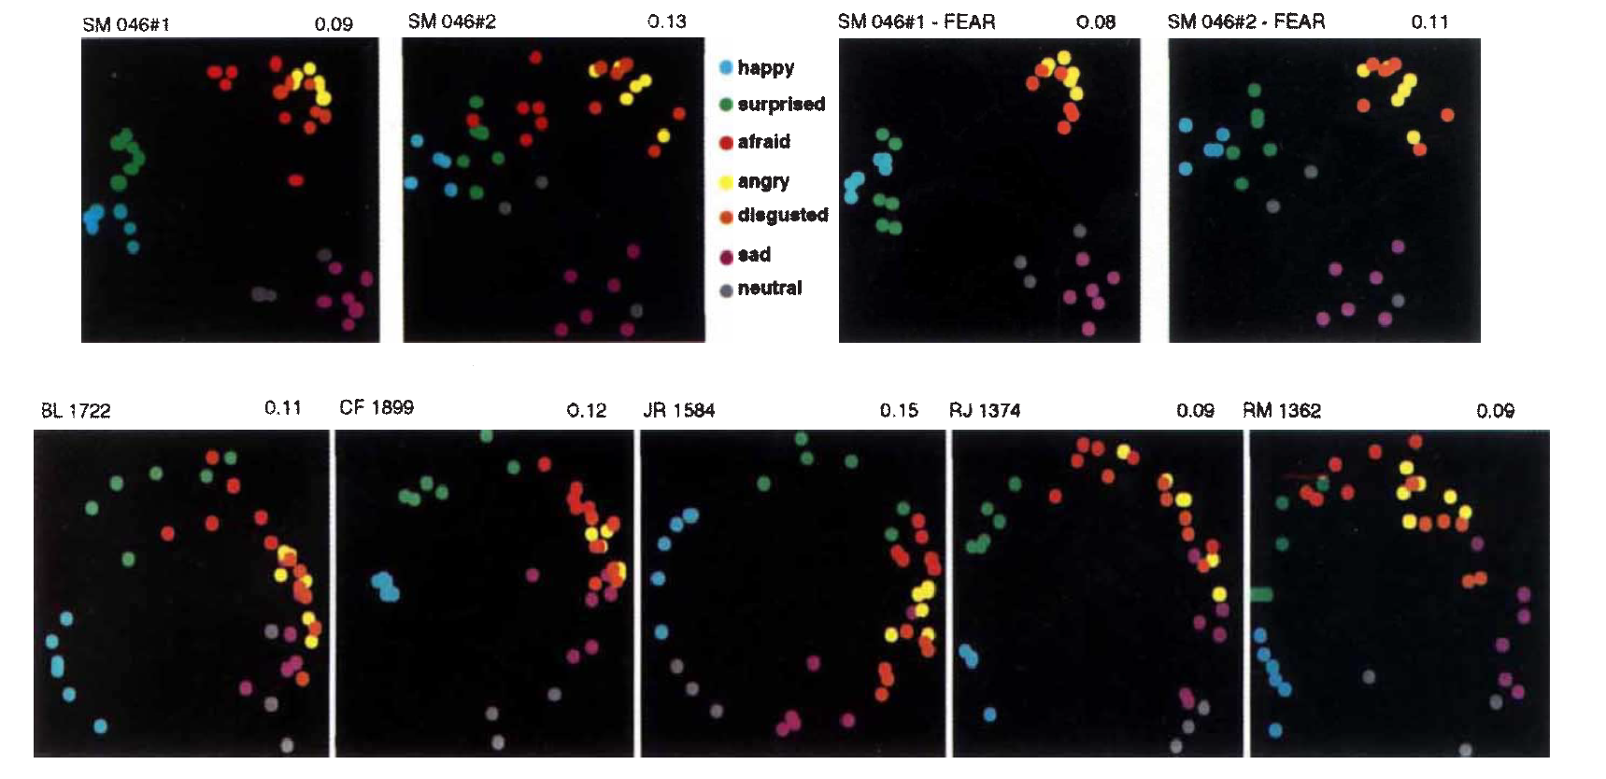Adolphs, Tranel, Damasio, H., & Damasio, A (1994) investigate a woman, S.M., who suffers from Urbach-Wiethe which caused the almost complete destruction of her amygdala. S.M. had no difficulty with identity, correctly recognising 19 familiar faces, some of which she had not seen in years. The experiment was conducted with S.M. and 12 brain-damaged controls; the group were shown expressions of six basic emotions as well as neutral faces. The participants were asked to rate each image according to different emotional adjectives. During this experiment, S.M. rated fear, anger and surprise less intensely than the controls. When the results were compared to controls with no history of brain-damage it showed that S.M. had severe impairment when recognising fear. These results suggest, when concerning singular emotions, that the amygdala is specific to recognising fear. S.M. was next tested on her ability to find similarity with different expressions (see below). S.M. grouped emotions much more discretely regardless of whether fear was included in the test and her results were quite a contrast to the other controls’. Obtaining the same results in tests where fear was absent indicates that her inability in determining similarity in emotions is independent of her impairment in recognising fear. S.M. was finally tested on her ability to recognise multiple emotions in a single facial expression. The results showed she could only recognise the main emotion being displayed. S.M. was able to relate expressions of the same emotion but failed with those of displaying similar emotions. These results quite confidently show that the amygdala is key in recognising fear and combinations of multiple emotions but is not utilised when it comes to facial recognition.

Source: Figure 3 of Adolphs et al. (1994).

**Conclusions**

The initial findings of Bruce & Young seem to still be, for the most part, relevant to this day with few disputing arguments available. Facial identity and facial expression do, for the most part, appear to be separate cognitive systems but, as Pell & Richards have found, there are certain amounts of crossover in some areas of processing, although, in others, shown by Adolphs et al., they are completely independent. Plenty of studies have shown some crossover in facial identity recognition and expression analysis but a sound model is yet to be established for these two aspects of the cognitive system. Despite many examples of these crossovers more research should be done to conclude the exact situations where the two systems are reliant on each other. Through my research on different papers, I have found plenty of examples of research carried out on how humans process facial expression and interpret emotions but there has been little research, in comparison, in facial recognition. Diving deeper into this area of the cognitive system could yield greater insights into how closely related the two systems are and could help lead towards a more reliable model than that of Bruce & Young, accelerating our progress into developing computer systems to carry out the same tasks.

References

Adolphs, R., Tranel, D., Damasio, H., & Damasio, A. (1994). Impaired recognition of emotion in facial expressions following bilateral damage to the human amygdala. *Nature*, *372*(6507), 669.

Bruce, V., & Young, A. (1986). Understanding face recognition. *British journal of psychology*, *77*(3), 305-327.

Pell, P. J., & Richards, A. (2013). Overlapping facial expression representations are identity-dependent. *Vision research*, *79*, 1-7.

Sinha, P., Balas, B., Ostrovsky, Y., & Russell, R. (2006). Face recognition by humans: Nineteen results all computer vision researchers should know about. *Proceedings of the IEEE*, *94*(11), 1948-1962.